TBMJA application 2.2 data validation observations:

Observation1: Beneficiary referred for sputum in application but database level its showing "0"
352978022085
Observation2: BeneficiaryID-909482705424 medication data available under database but after submission data showing blank under application side.
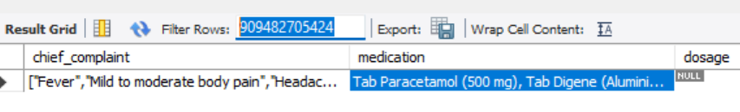

Observation3: Visit_date we are getting time as zero's
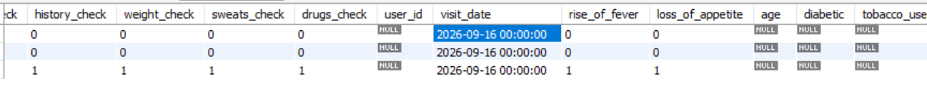

Observation4: BMI additional column getting under tb_screening table

Observation5: Under demographic side extra field contains health information like BMI, Temparature, etc.
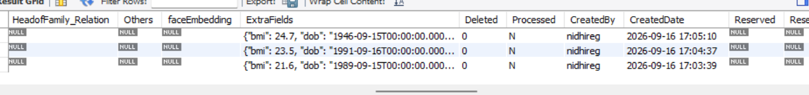

Observation6: Vanid=0 we identified under UAT database, need clarity on it . because production showing vanid data then same need to reflect under UAT as well

