Field Testing Observations Day 4
  - Application and Integration Testing: X-ray AI and TrueNat Devices

Connectivity and Device Setup
The camp hub went live at approximately 10:40 AM, once all device setup was completed.
A Wi-Fi router with a SIM was connected as the primary network.
The router repeatedly dropped its connection to the tablet and the X-ray AI laptop, so we switched the setup to a dongle-based connection.
The dongle-based connection proved stable for both the laptop and the tablets, with no further disconnections observed.
Once all devices were on the dongle, data synchronization ran smoothly.
The X-ray AI and TrueNat devices were the exception — both had difficulty establishing and holding a connection to the network.
The offline laptop was able to ping the X-ray laptop, but the API continued to report as down. On raising this with the ProRAD team, they advised restarting the dongle and their application and then reconnecting; after doing so, the connection was established.
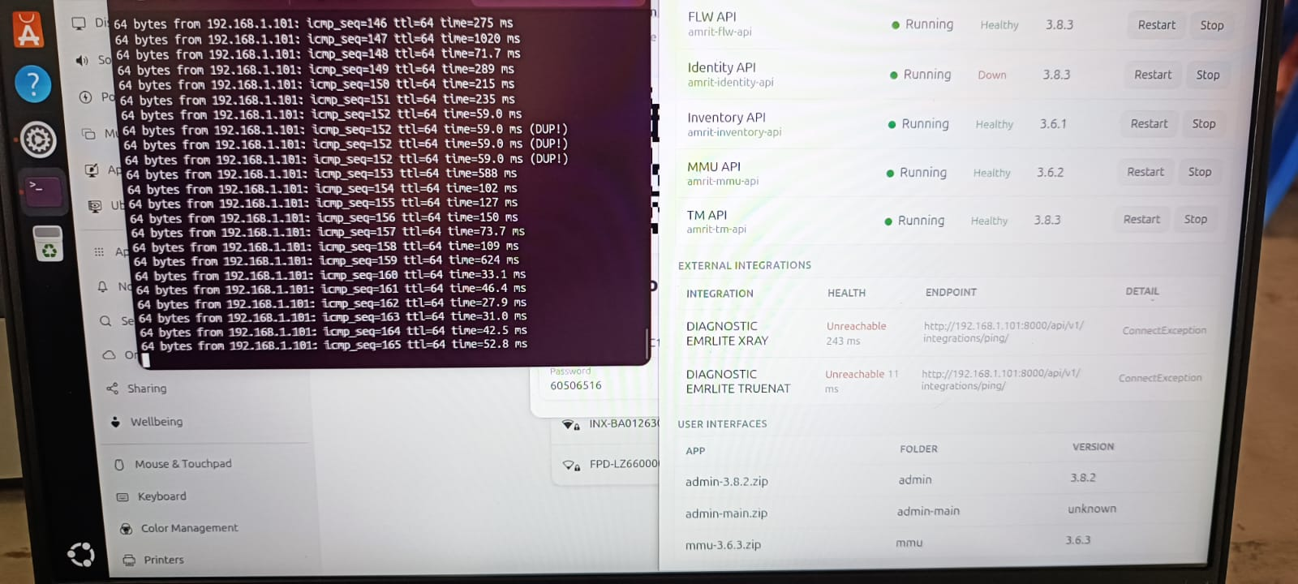

ProRAD and TrueNat Observations
The ProRAD software received duplicate work orders from the StopTB App, even though the app had sent only a single request.
The TrueNat device threw an error after connecting to the router. Following the ProRAD team's instructions, we restarted the dongle and reconnected the device, after which the referrals became visible in TrueNat.
However, duplicate names were displayed on screen.
The ProRAD software throws an error after every three successful X-rays. On inquiry, the ProRAD team confirmed this is a hardware issue at their end, which they will rectify.
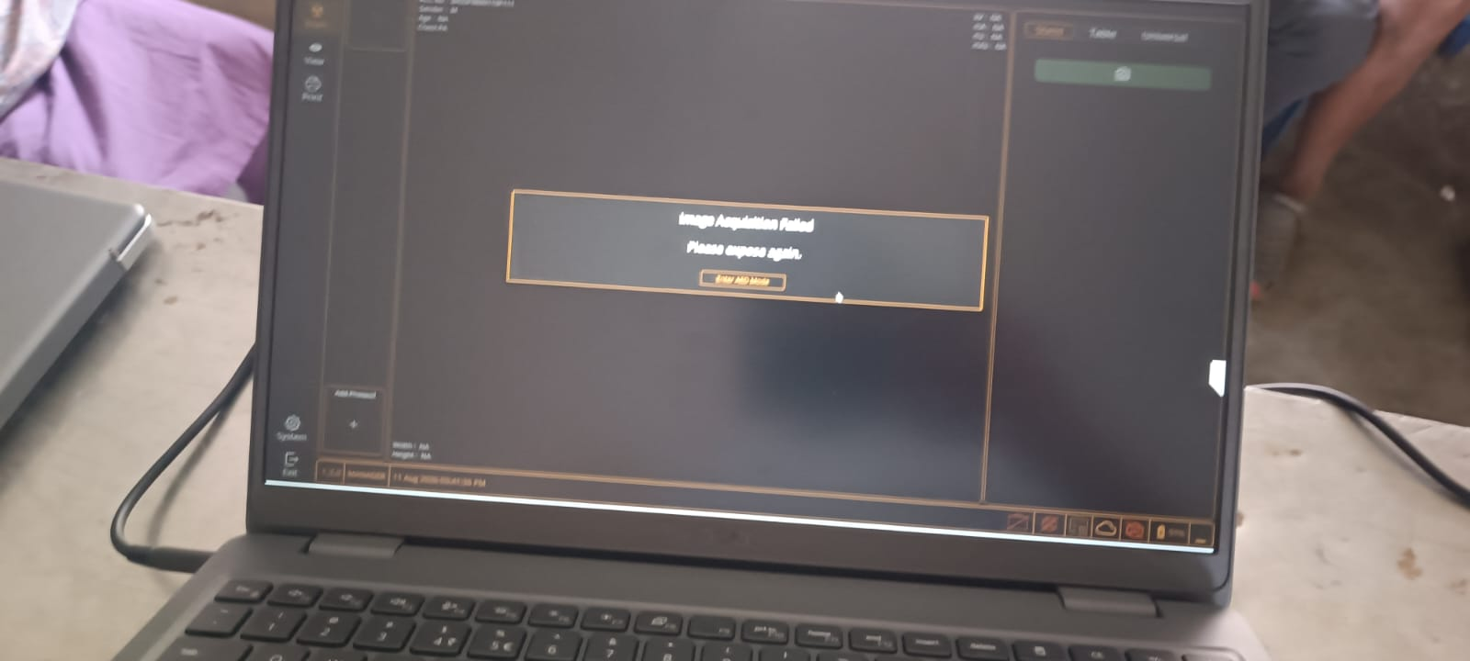

StopTB App Observations
In the StopTB App, a few records in the X-ray referral section were showing as “Track.” The development team confirmed that this occurs when the connection is lost, which moves the record to the manual error section.
After logging out and logging back in, the same records reverted to “Pending” status.
For a few records, both the X-ray and TrueNat statuses were displayed as “Track” and “Pending.”

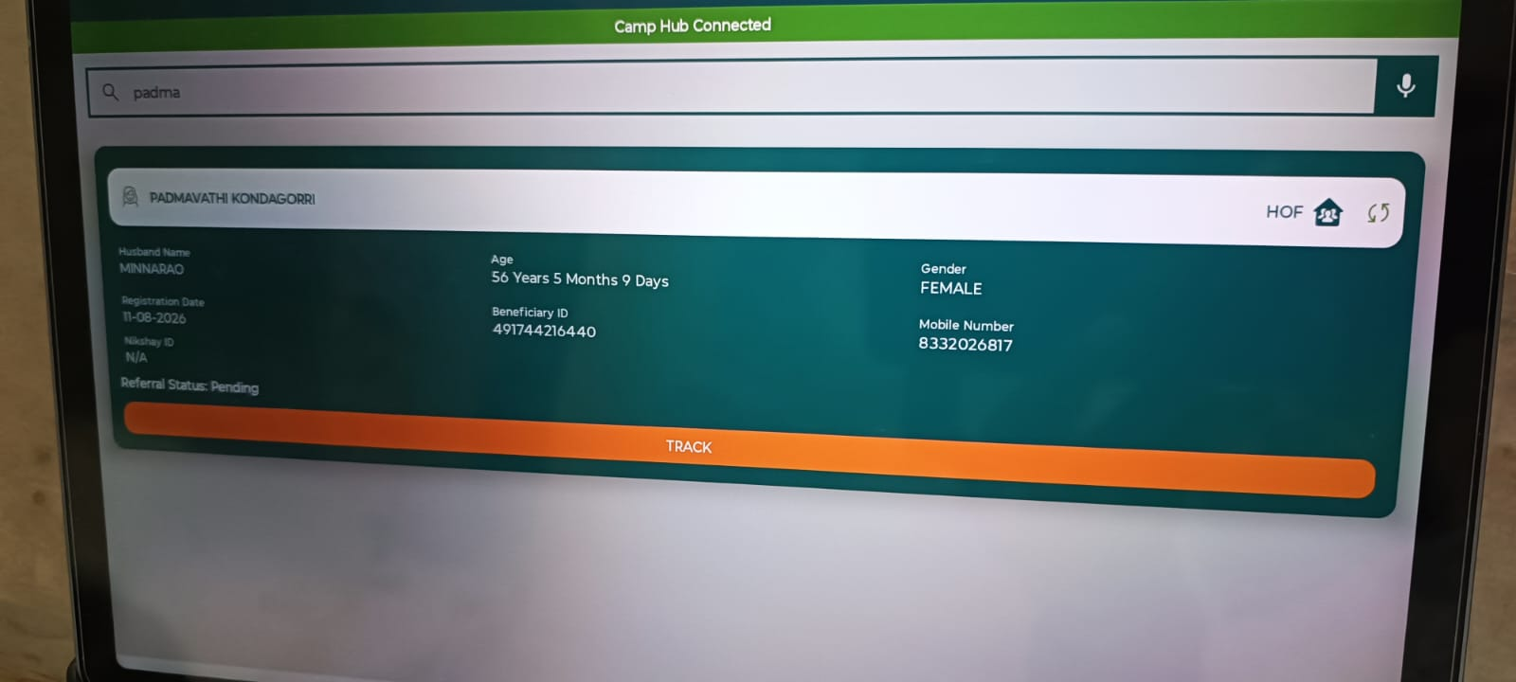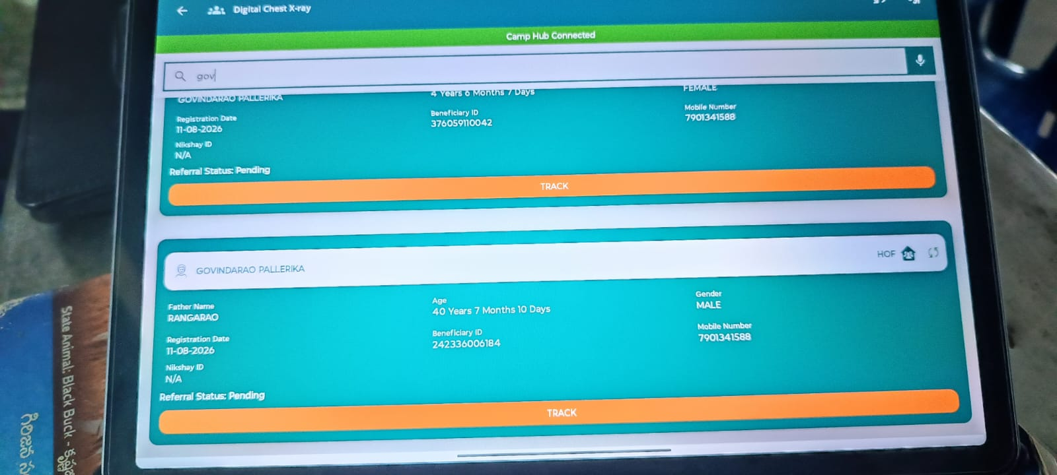

Results were also verified on the TrueNat machine and matched what was displayed in the app.

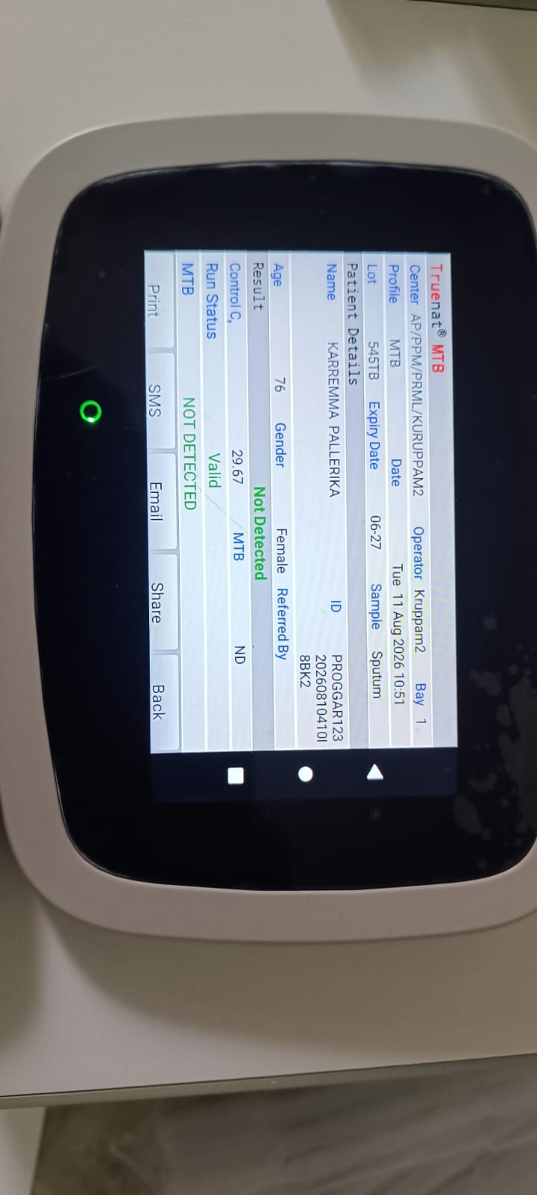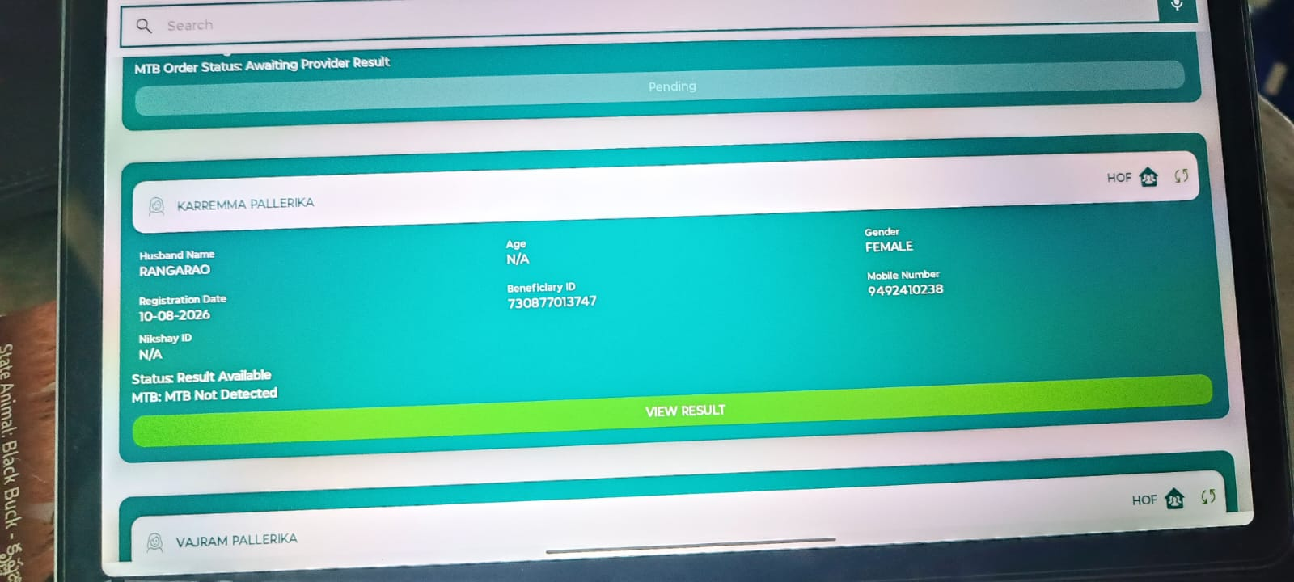

Results Turnaround & Counter 3 Gap
X-ray results reached our devices with significant delay — most results remained pending for over an hour. The ProRAD team confirmed the results were available in their software but were not being pulled from our end. The relevant logs have been shared with the development team.
The Counter 3 resource has to walk over and check the referral section for results, and by the time she does so the beneficiary has often already left the camp. As a result, none of the abnormal X-ray cases referred for TrueNat testing were completed, as samples were not collected.
This is a clear gap. Counter 3 needs a dedicated tablet for visibility of results so that sputum can be collected on the spot. Where results are delayed, the beneficiary leaves the camp and the sample has to be collected later if the case is found presumptive.

Logs and Backend Data Sync
The required logs from the tablets and the offline laptop have been shared with the development team, and the logs from the ProRAD laptop have been shared with the ProRAD team.
The sync from the offline laptop to the central server was also completed successfully.

Door-to-Door Enumeration
Door-to-door enumeration testing was also carried out alongside the camp activity.
The registrar traveled to the village and captured the data in the app in offline mode, completing 10 household registrations covering 16 beneficiaries.
On returning to the camp, the tablet connected to the camp network automatically and all household data synced through without any manual intervention.

Household Registration Form — Observations and Change Requests
- The household registration form needs additional mandatory fields.
- A search option is required for village selection.
- The PIN code auto-fill field needs to be checked.
- A default “Unknown” option should be available in the relevant fields.
- The search option in the household and beneficiary screens does not return an exact match.
- The line-listing order is yet to be decided.
- In the Examine section, completing a single form turns the section green, so users assume the remaining forms are already filled and skip them.
- The counts on the dashboard do not match; the numbers need to be reviewed.
- For the “Availability of toilet” field, users have asked for a more precise set of options to select from.

Camp Volumes
Total registrations completed in the app over two days: 108 — 92 from the camp village and 16 from the three surrounding villages.
X-rays conducted on the ProRAD software: approximately 60.
TrueNat tests conducted: 1, as the remaining cases were still due for sample collection.

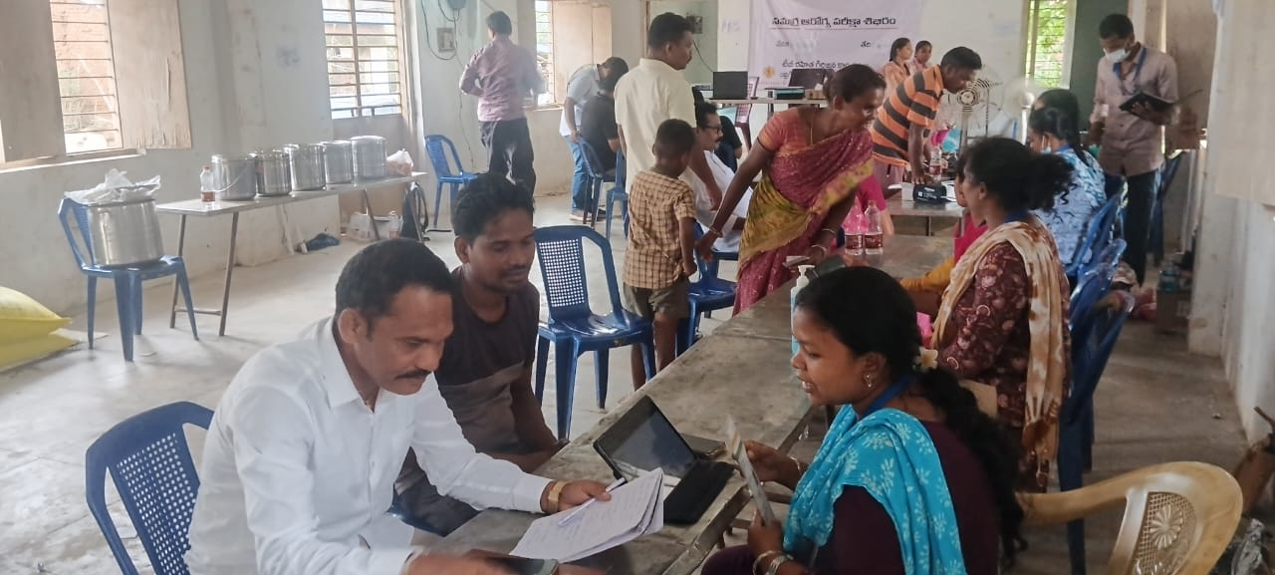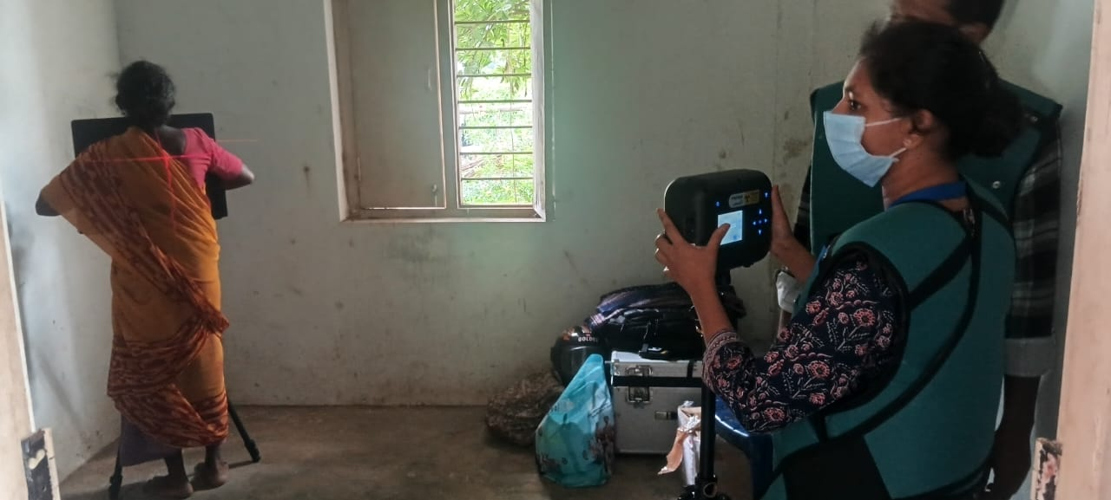

Next Steps
- ProRAD team — Fix the hardware issue causing an error after every three successful X-rays, and confirm a target date.
- ProRAD + Dev teams — Jointly investigate why X-ray results are not being pulled from ProRAD to our devices; logs already shared.
- Dev team — Resolve the duplicate work orders sent from the StopTB App and the duplicate names appearing on the TrueNat screen.
- Dev team — Review the “Track” / “Pending” status behavior in the X-ray referral section so records do not shift state after logout and login.
- Field ops — Provide a dedicated tablet to the Counter 3 resource so results are visible in real time and sputum can be collected before the beneficiary leaves the camp.
- Field ops — Standardize on dongle-based connectivity for all camp devices, with the Wi-Fi router retained only as a backup.
- Testing team — Re-test the full X-ray and TrueNat integration flow once the above fixes are in place.
- Dev team — Add the required mandatory fields to the household registration form and confirm the final field list.
- Dev team — Provide a search option for village selection, and fix the household and beneficiary search so it returns an exact match.
- Dev team — Verify the PIN code auto-fill behavior and add a default “Unknown” option in the relevant fields.
- Dev team — Fix the Examine section so it turns green only when all forms are completed, not after the first one.
- Dev team — Review the dashboard counts and reconcile the numbers against the app data.
- BSA team — Finalize the line-listing order and define a more precise option set for the “Availability of toilet” field.
- BIDA team — Review the backend data against the logs shared and confirm whether the records are landing correctly on the central server.

