DOCUMENT FOR THE CTI_GET_DISP_COUNT

The CTI_GET_DISP_COUNT will give the count of the Disposition of the campaign.

Api url : https://server_ip/apps/CZUtilAPI.php

Below are the parameters that need to be passed to the API.
{
"transaction_id": "CTI_GET_DISP_COUNT",
"campaign_id": "Engineers_1b3269",
"disposition" : "transfer",
"date" : "2025-12-22",
"enc_flag" : "0"
}
date, enc_flag is optional and if user pass "enc_flag" : "1" the response will be received in encrypted form.
How To check the Working of the API.
Log file for the API : tail -f /var/log/czentrix/custom_api.txt
If only campaign is selected
response :
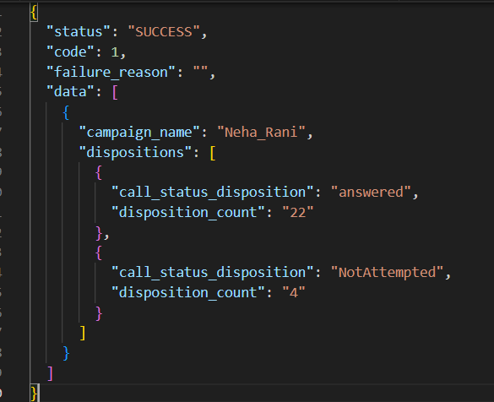

If only campaign is selected, the data will come according to the date you have selected and no date is selected than current date data will be visible.
response :
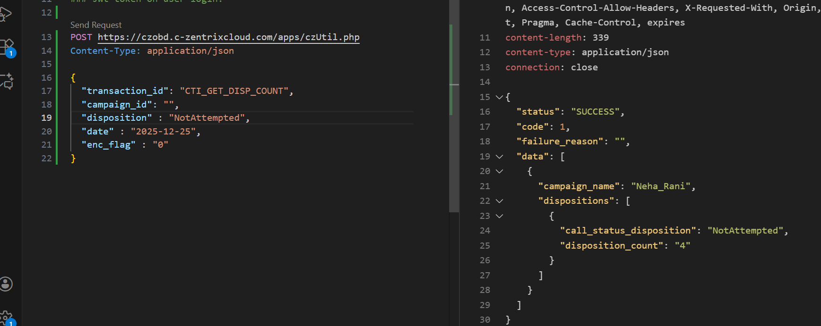
If date does not selected:
response :
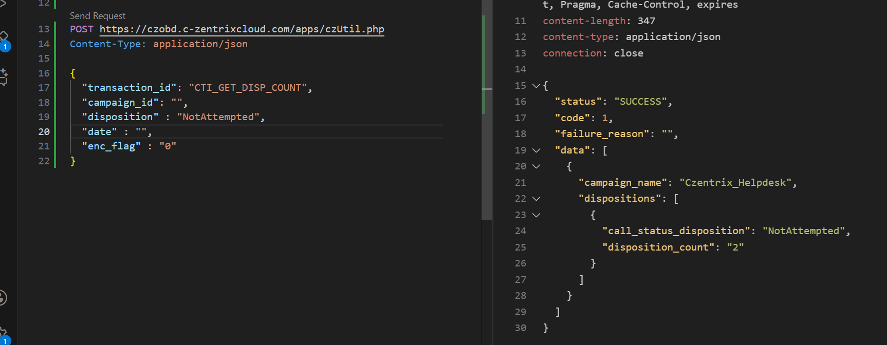
If enc_flag does not selected:
response:
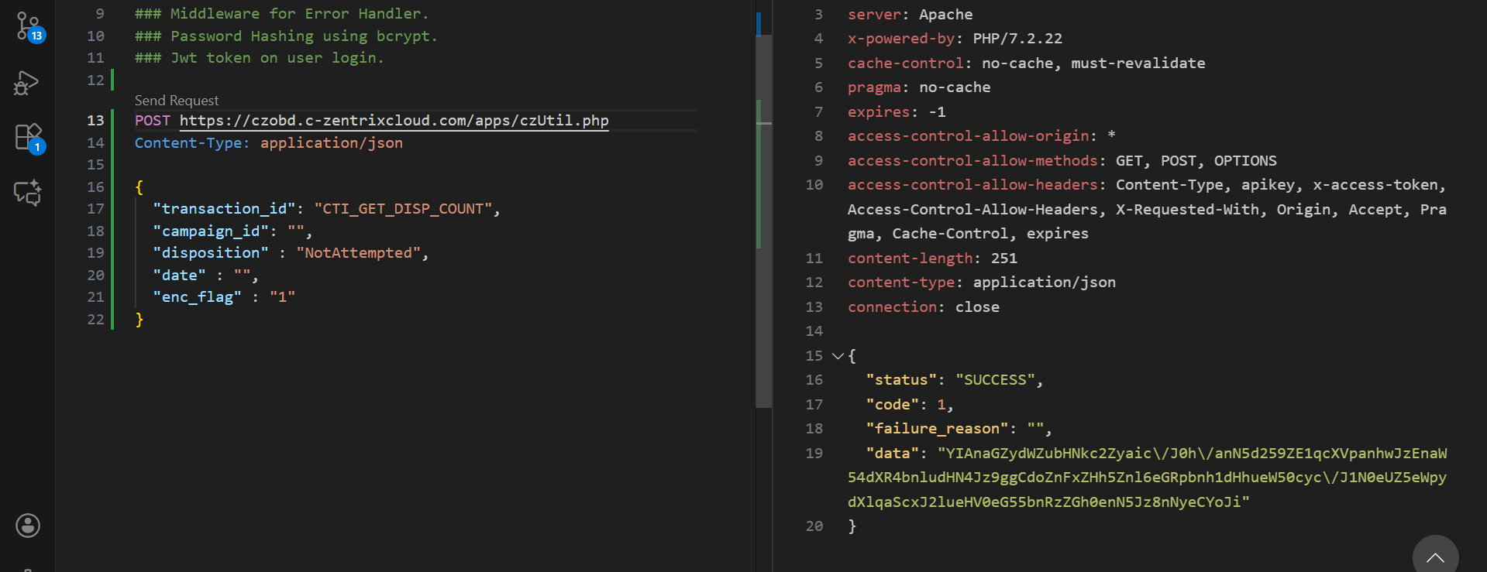
If the campaign_name send wrong.
Response:
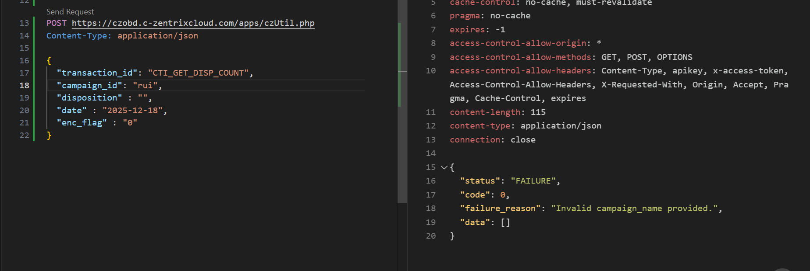
--> In log file /var/log/czentrix/custom_api.txt, you will get the Request Body Received , Response Returned, Executing Disposition Count Query.

