- Admin
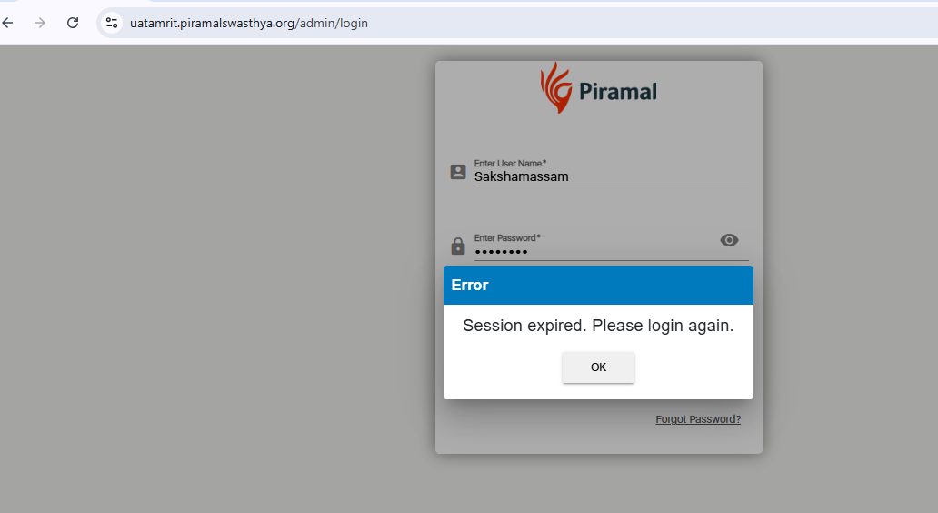

- ECD (getting everything blank)
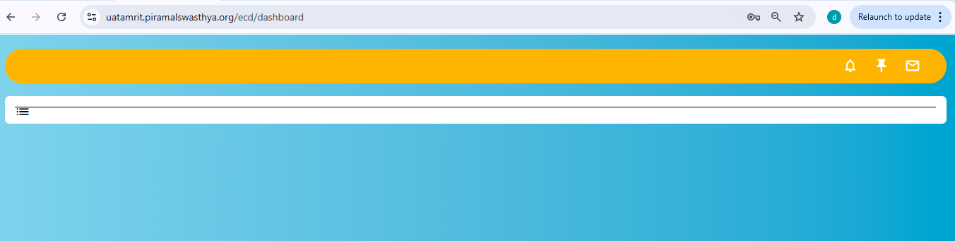

- TM
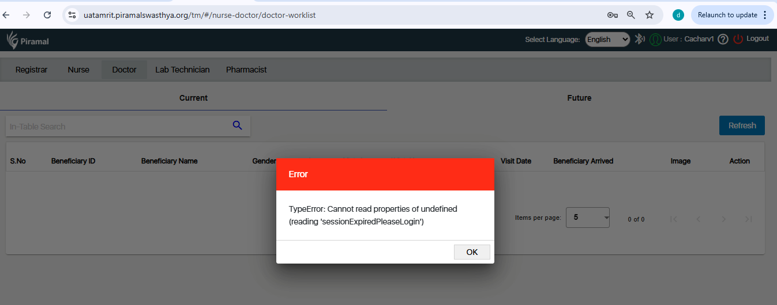

- HWC
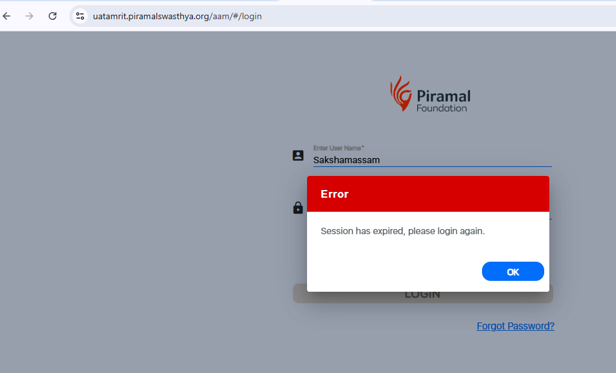

- While logging to HWC Inventory getting this screen:
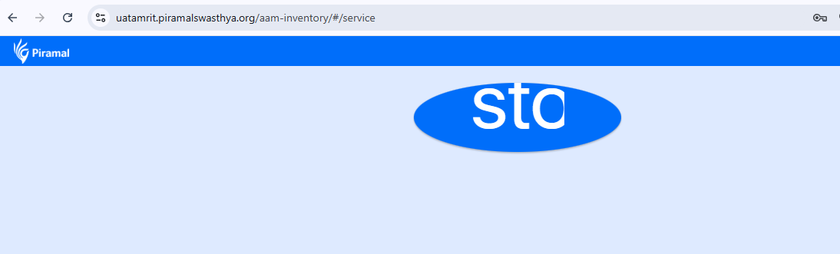

- 104 session not expiring, able to navigate:
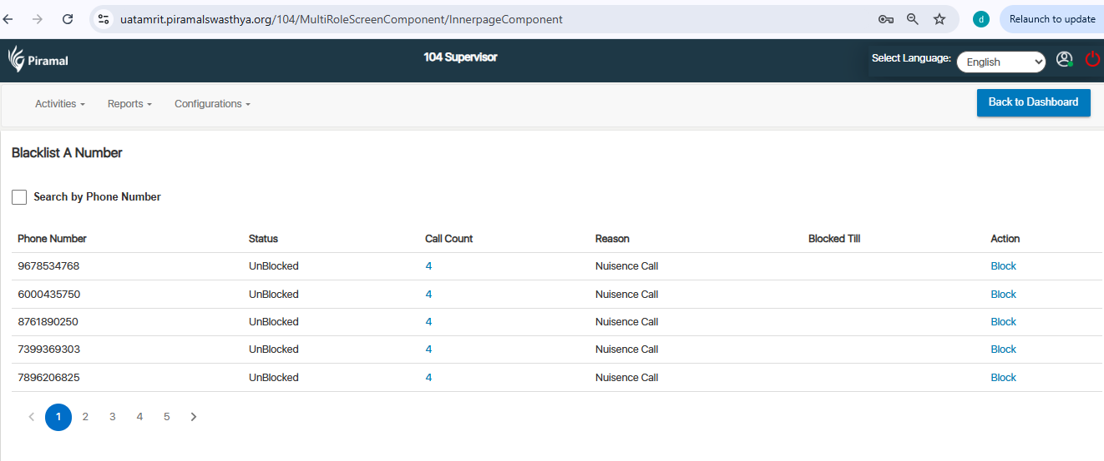

- 1097 session not expiring, able to navigate:
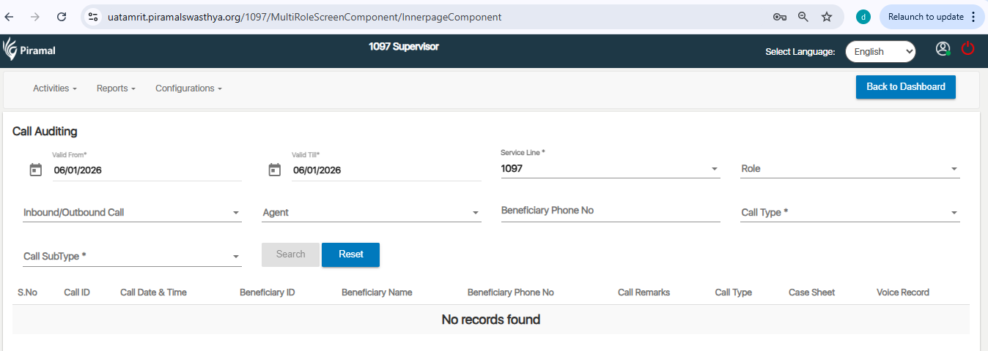

- MMU session not expiring, able to navigate:
