Offline MMU Data Sync Testing
Steps to be followed-
- Login to application
- Go to Datasync Tab
- Login by same user name and password
- Click on data sync.
- Below screen shot will show some of the tables as partially synced.
- 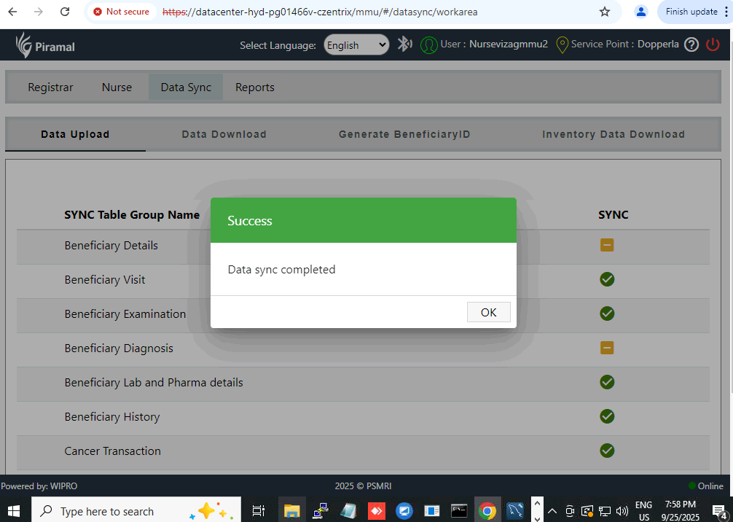
- 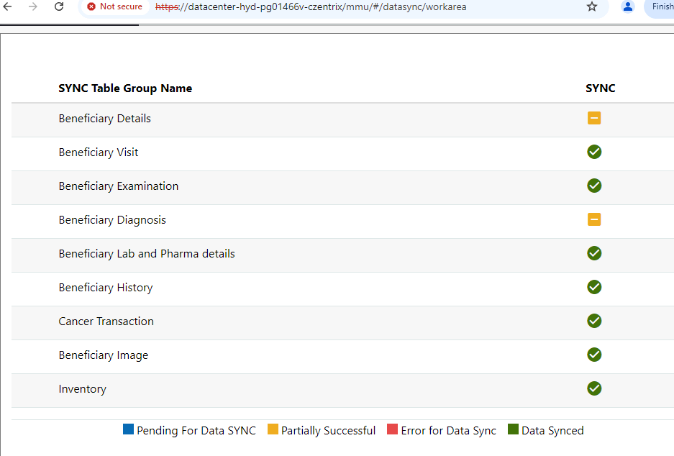

DB data sync with error-
 | 3802 | 199408458 | 5847 | 10 | 3.00029E+13 |  |  |  |  |  |  |  |  | 0 | F | Doctorvizagmmu2 | 9/25/2025 19:57 |  | 9/25/2025 19:57 |  | 29 |  | 9 | Nursevizagmmu2 | 9/25/2025 19:57 |  | Record check failed: Invalid identifiers provided.
 | 3801 | 199408458 | 5847 | 10 | 3.00029E+13 | 3 | Abdominal Pain |  | 139313005 |  |  |  |  | 0 | F | Doctorvizagmmu2 | 9/25/2025 19:57 |  | 9/25/2025 19:57 |  | 29 |  | 9 | Nursevizagmmu2 | 9/25/2025 19:57 |  | Record check failed: Invalid identifiers provided.
 | 3800 | 199408458 | 5846 | 10 | 3.00029E+13 | 3 | Abdominal Pain |  | 139313005 |  | 2 | Hours |  | 0 | F | Nursevizagmmu2 | 9/25/2025 19:57 |  | 9/25/2025 19:57 |  | 29 |  | 9 | Nursevizagmmu2 | 9/25/2025 19:57 |  | Record check failed: Invalid identifiers provided.

