Offline MMU Download Master Testing-
Steps to be followed-
- Login in admin module.
- Go to project configuration tab.
- Type project name as MMU.
- Example I have deactivated other information.
- Below screen shot for deactivated other information which will not be visible in offline mmu after doing download master.
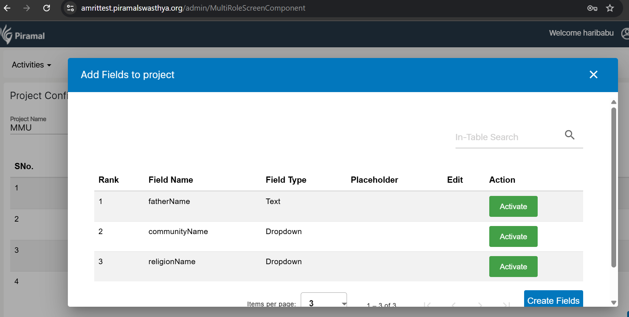
Steps to be followed-
- Login to application
- Go to Datasync Tab
- Login by same user name and password
- Click on data download.
- Below screen shot once download success.
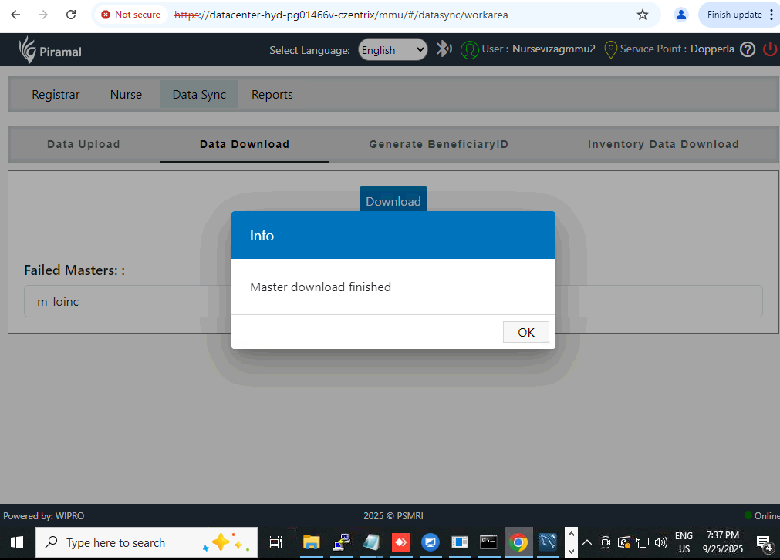
Steps to be followed-
- Login in offline mmu application
- Go to registration page.
- Below screen shot you see other information in registration screen will not be available.
