Assamese Language - MMU Application
- Connect Bluetooth
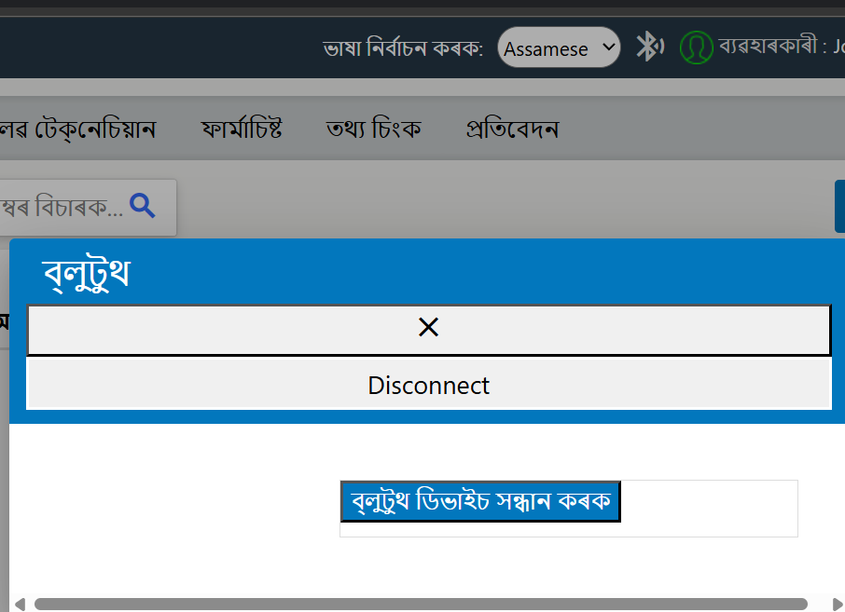
- Data Sync –
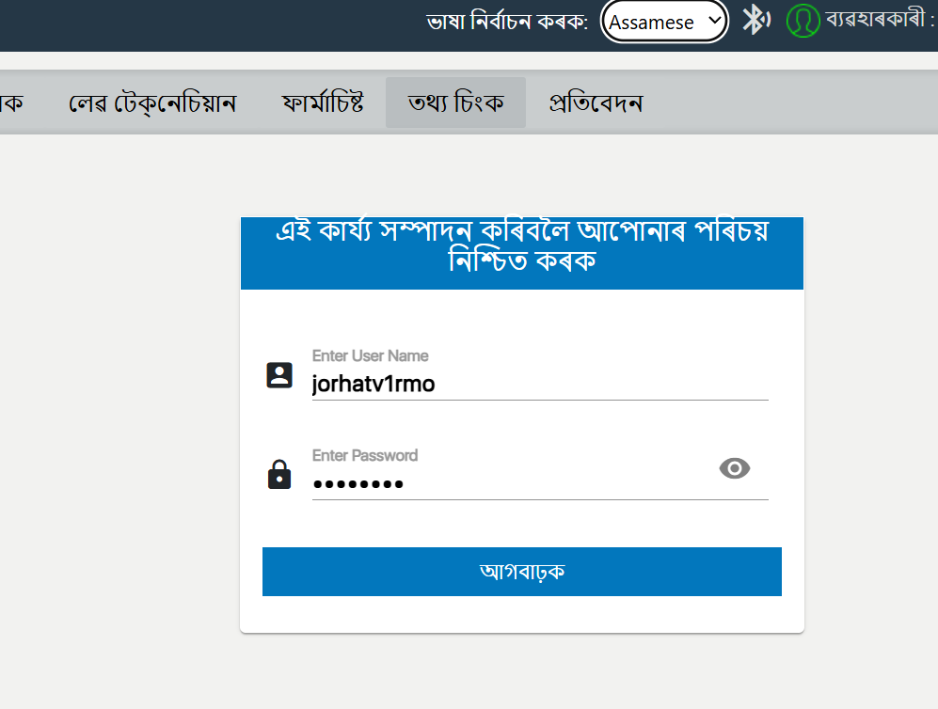
- MMU Investigation-
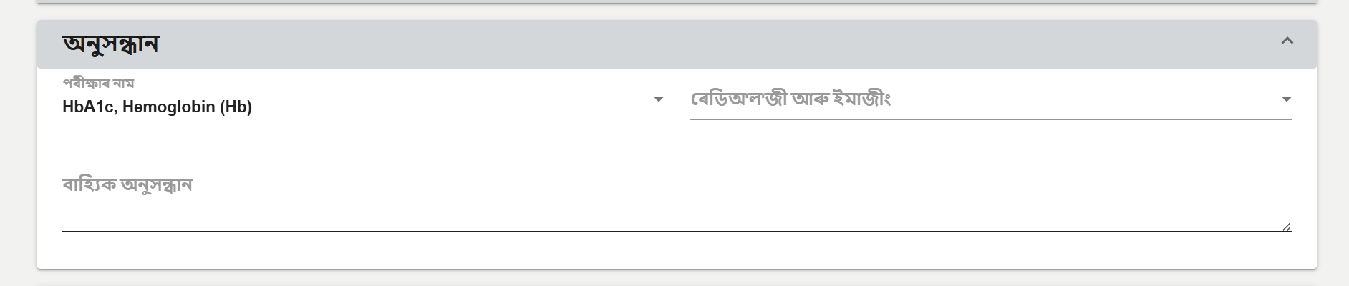
- MMU Prescription-
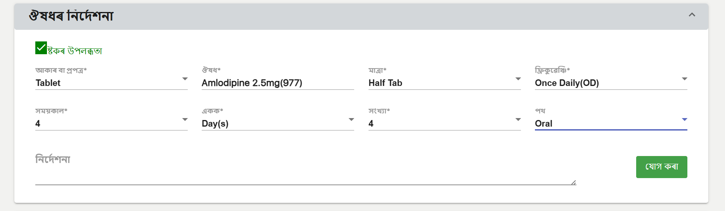
- MUU External Investigation-
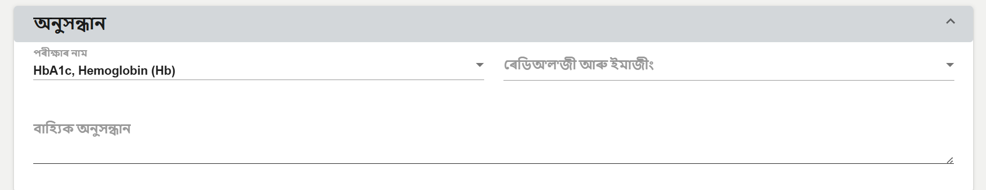
- MMU Revisit & Refer
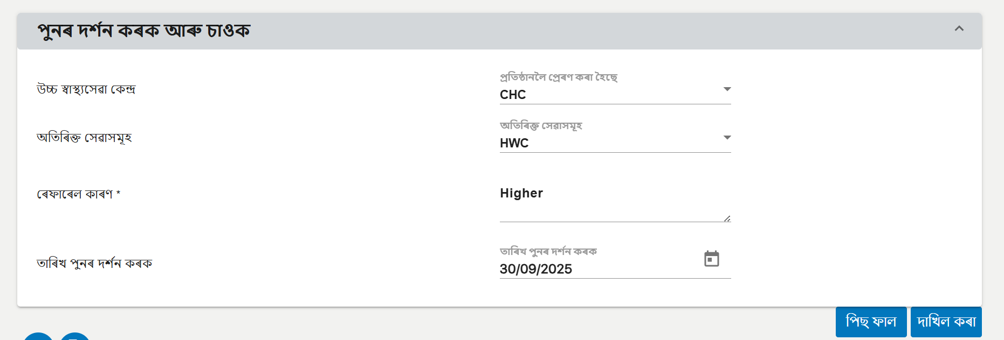
- RBS Remarks-
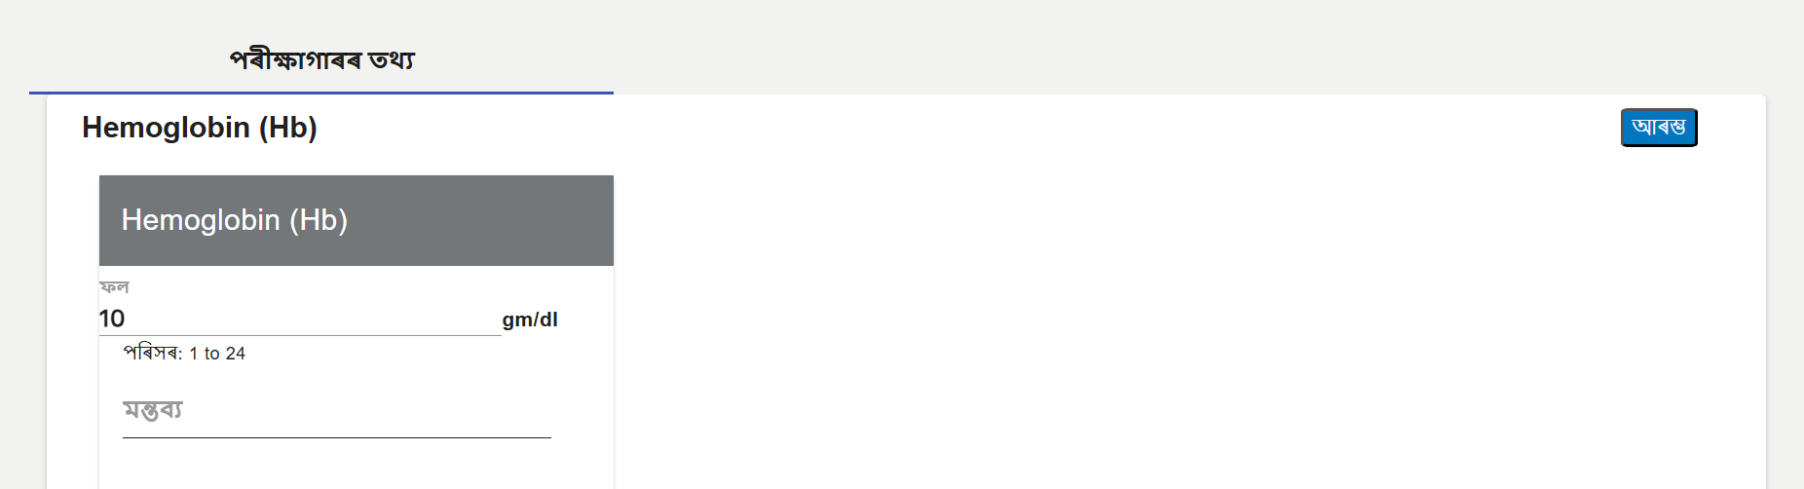
8. Prescribe Drugs-
