Step 1. Register a beneficiary.
Step 2. Do a full flow of a beneficiary.
Step 3. Do a advance Search.
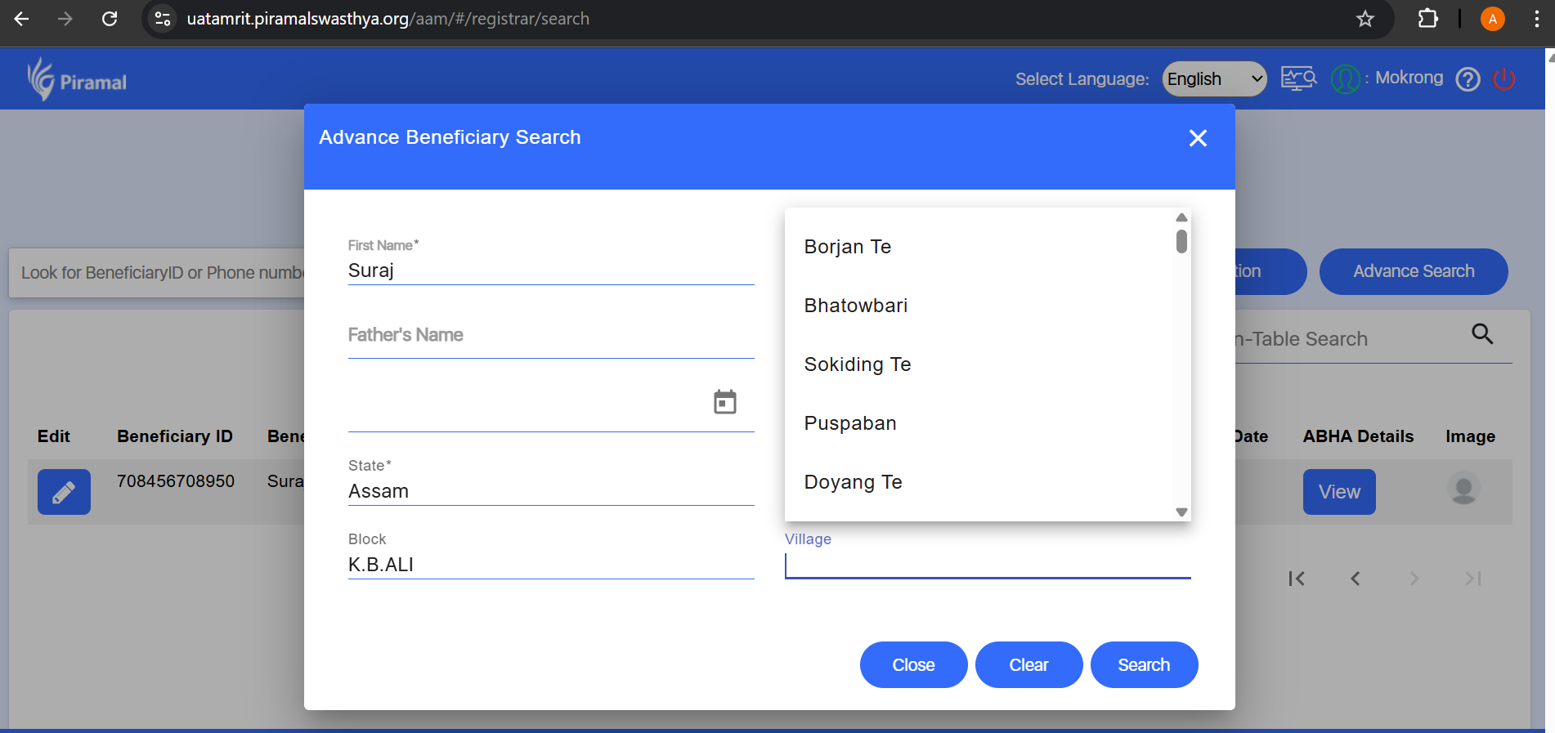
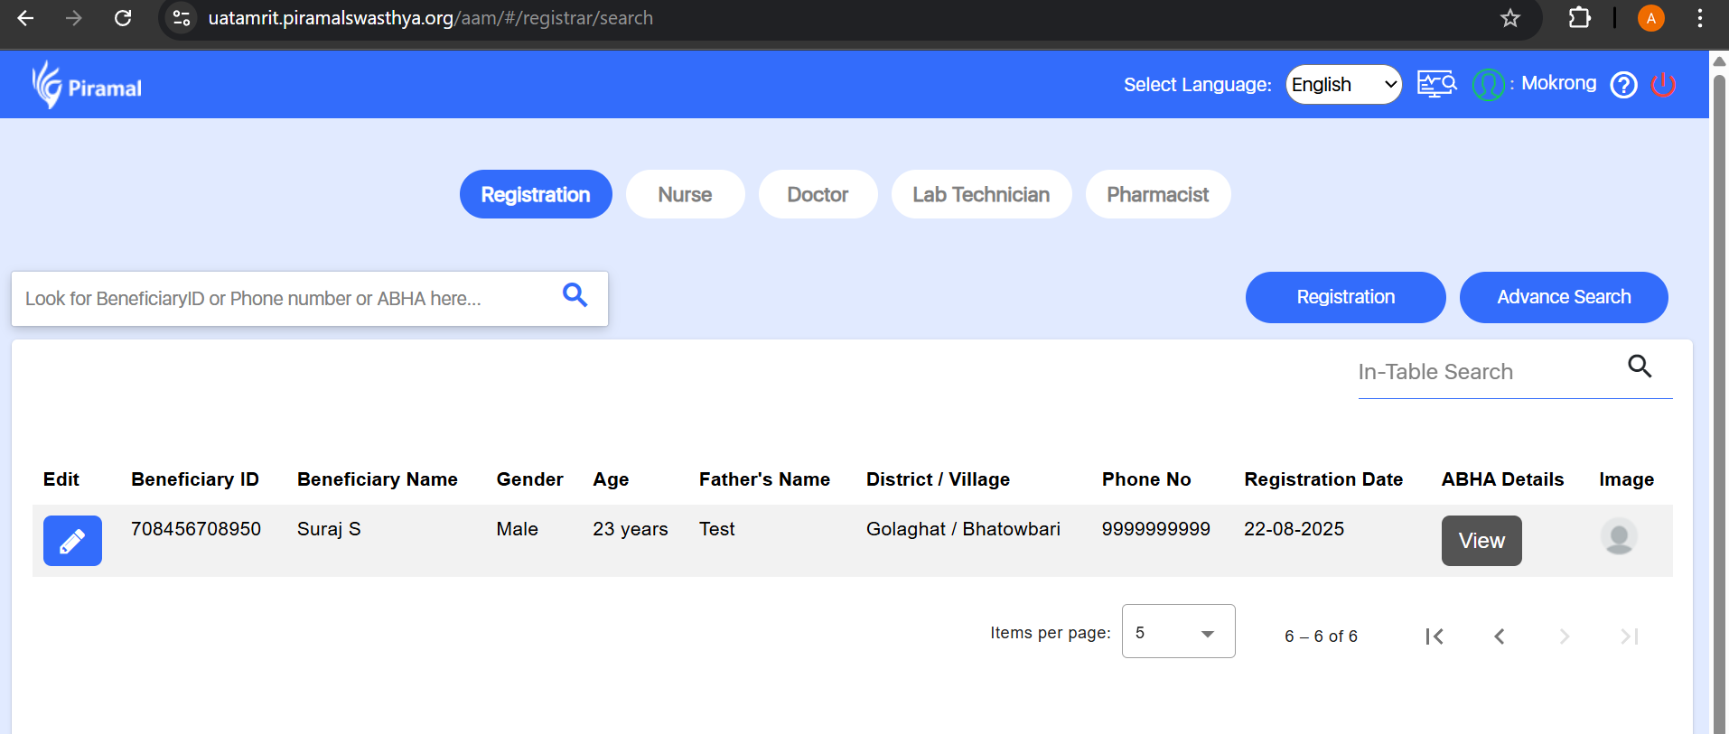

UI issue found in Pharma worklist-
If I am clicking on left side toggle bar to see beneficiary details the Tablet show till Tabl. Please find below screen shot.
