MBP WhatsApp Share - Incorrect EDD Display and Null Values Showing for LMP
FLW-106
Username:8800000007
Password: Test@123
Click on high risk,
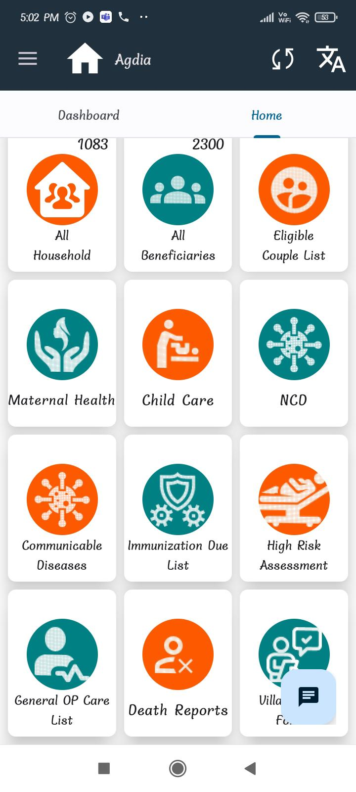
click on asses high risk in PW,
click on microbirth plan,
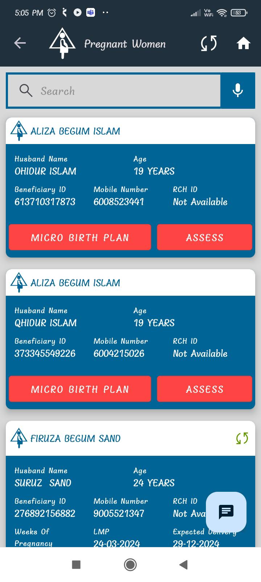
Fill required details,
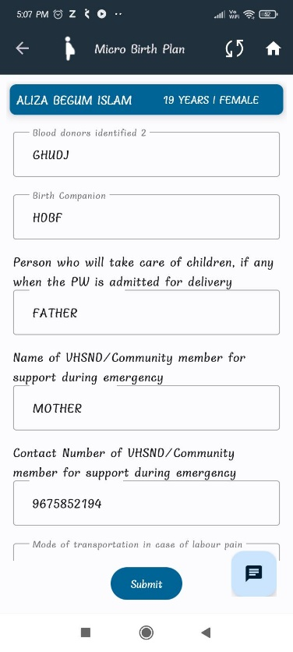
click on follow up HRP women,
click on share button,
Here LMP date and EDD date is coming
it's working fine,
