Implement Age Group Filter and Speech-Enabled Search in Adolescent Module
FLW-127
Username: 8800000007
Password: Test@123
Click on child care,
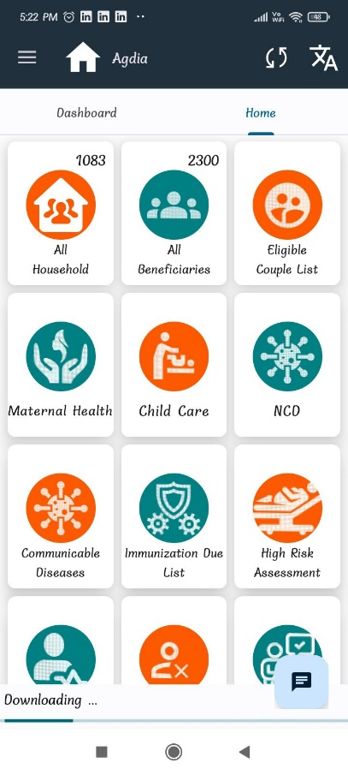
Click on adolescent list,
Here male, female age 10 below or 19 above is not coming,
It’s working fine

