Update Validation for LMP Date in Pregnant Women Registration Module
FLW-104
Username: 8800000003
Password: Test@123
Click on maternal health,
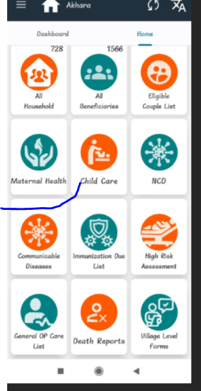
Click on pregnant women registration,
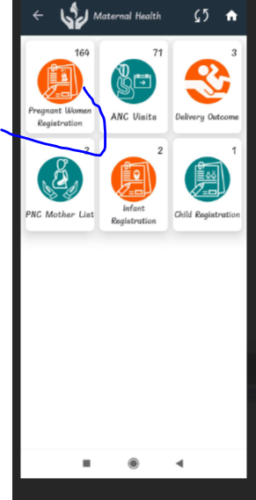
if taking date of registraton today's date please check LMP date previous 400 days is anable or not.
