Enable "Add ANC Visit" Button Based on Delivery Status and Manage "ANC Periods"Field
FLW-103
Username: 8800000003
Password: Test@123
Click on maternal health,
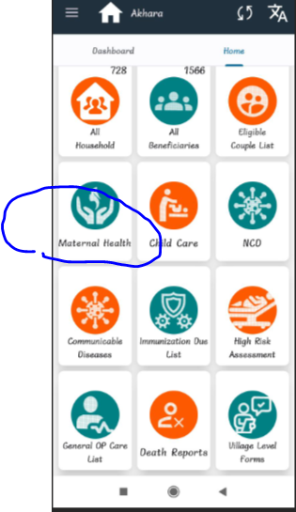
Click on ANC visit,
