UI Update: Add Icons for ANC Visit & Eligible Couple Registration
FLW-90

Username: 8800000003
Password: Test@123
Click on maternal health,
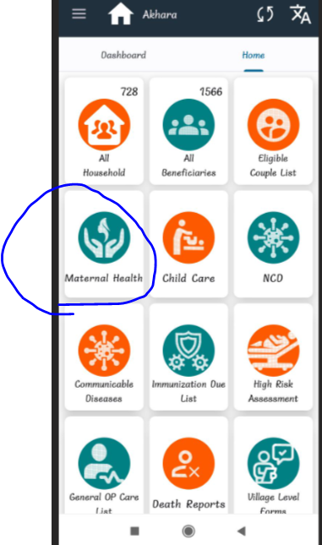
Click on ANC visit,
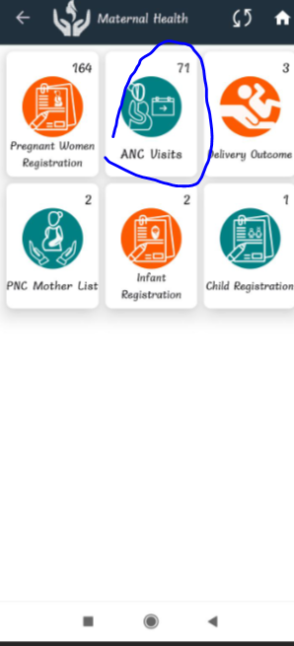

Click on add ANC visit,
Here showing particular fields icons,
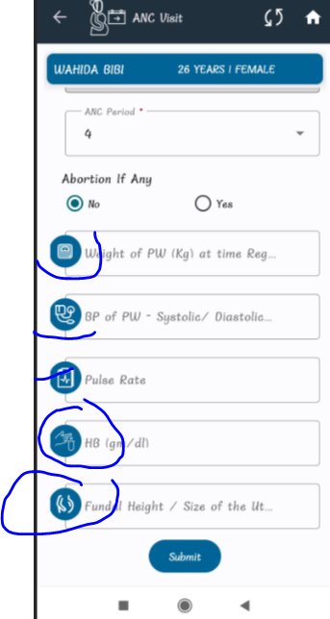
Click on eligible couple list,
Here it’s showing particular fields icons,
