ANTRA Injection Dose 1, dose2, Dose3, Dose4.
FLW-53
Username: 8800000003
Password: Test@123
Click on eligible couple list,
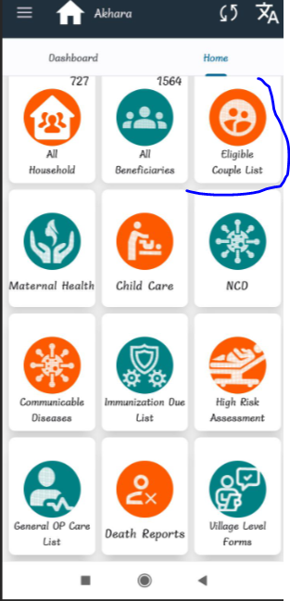
Click on eligible tracking list,
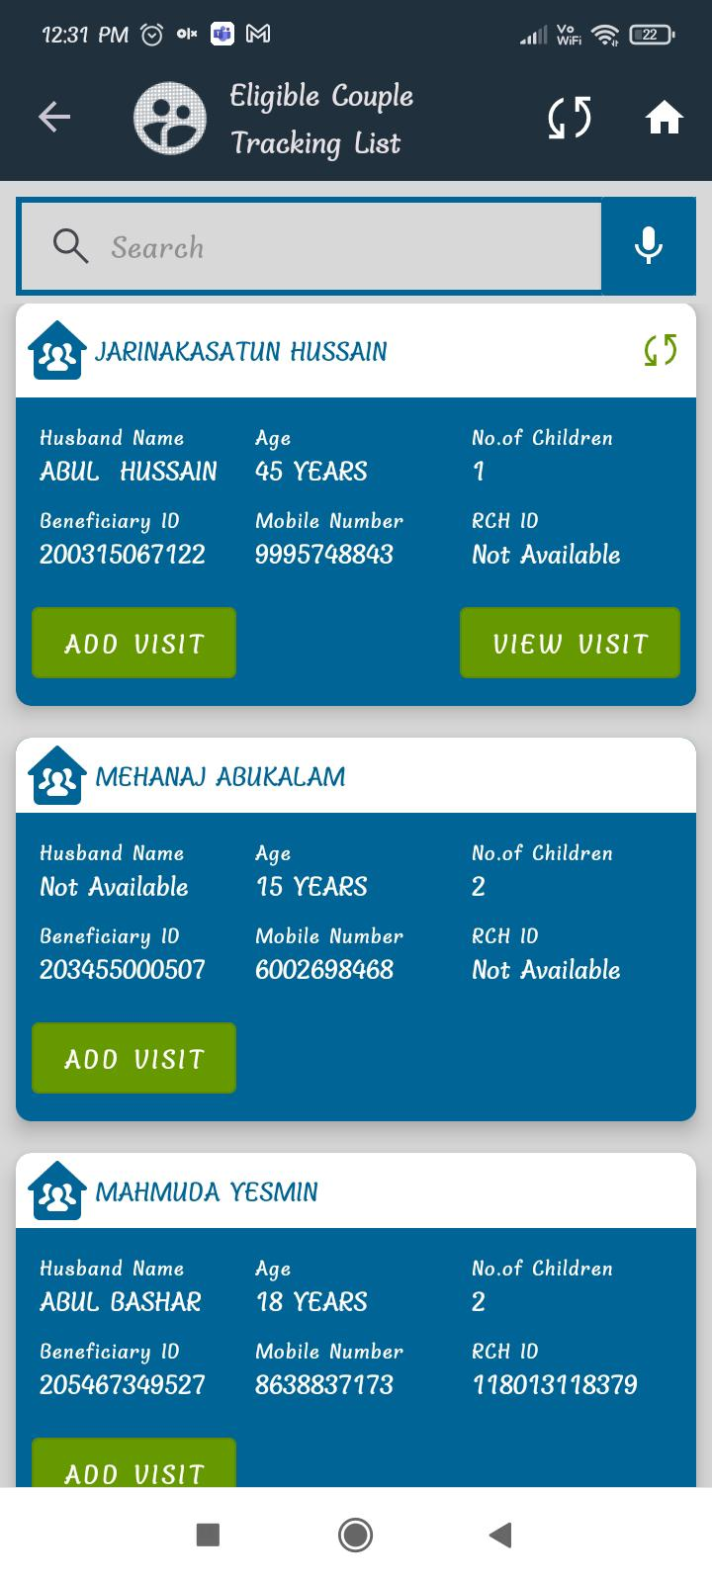
Fill below required details,
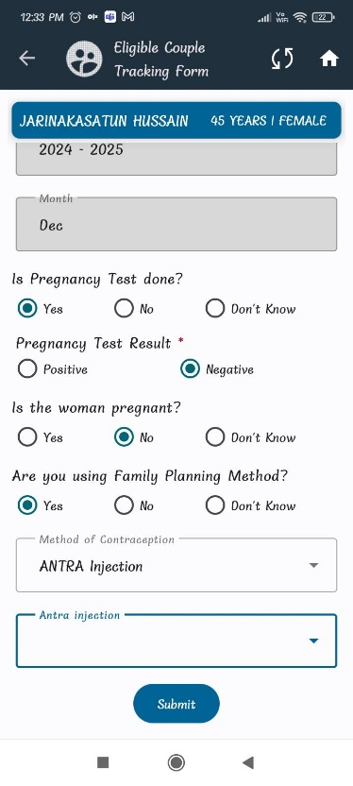
Here click on Antra Injection it will come 4 doses,
