Registration type is saving always as NewBorn
FLW-137
Username: 88000000003
Password: Test@123
Click on all household registration,
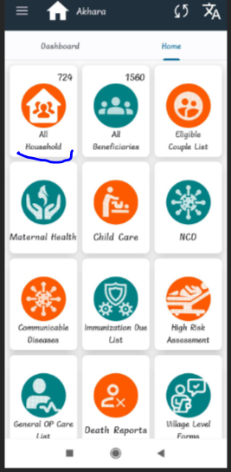
New registration Beneficiary name “Keshav” year 1,
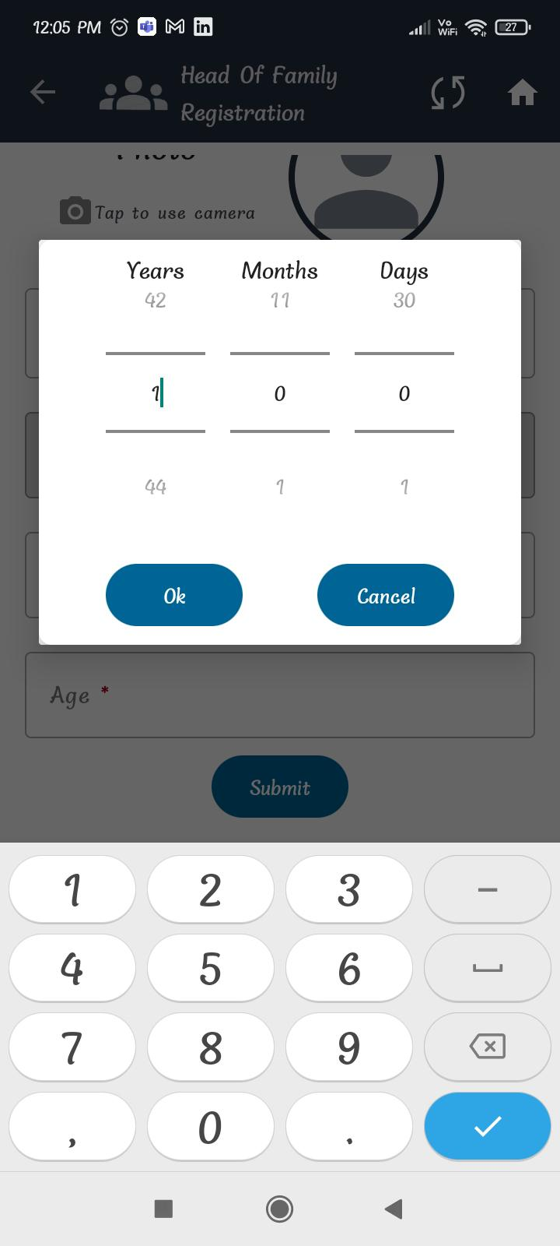
Again new beneficiary registration “Sagar” 18 year,
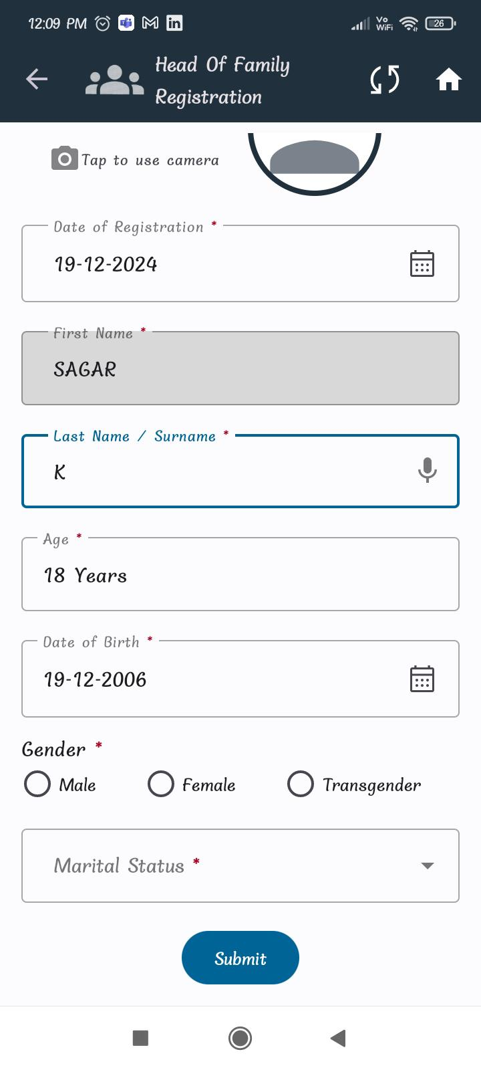
After this please check in DB
for Age 0 to less than 15 Years, registrationType="NewBorn"
and Age 15 years and above, registrationType="General Beneficiary".

