Set Default Values for Maternal Death and Abortion Fields to 'No'
FLW-130
Username: 8800000003
Password: Test@123
Click on “Maternal Health” ,
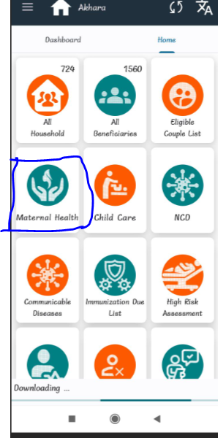
Click on ANC visit-> Add ANC visit,
Here Abortion field and maternal death field by default taking “NO”,

