Capitalization for First and Last Name Fields Regardless of Keyboard Input….Jira ID: 85
Choose English language Put username and password and click on login button,
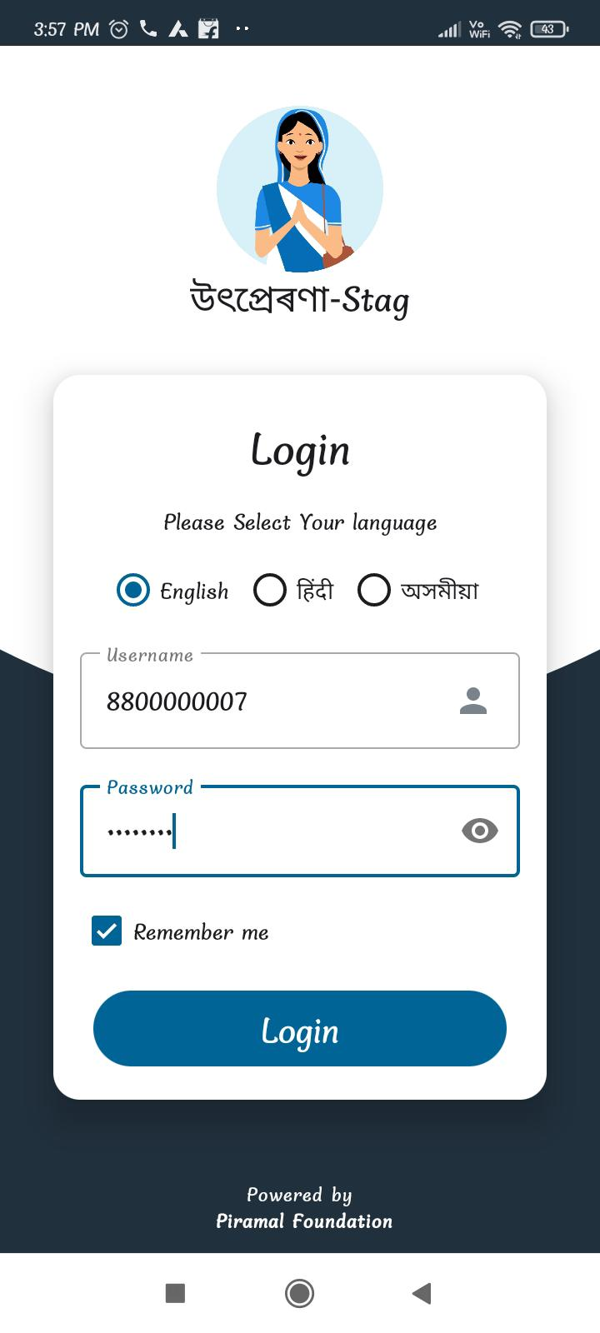
Click on All house hold,
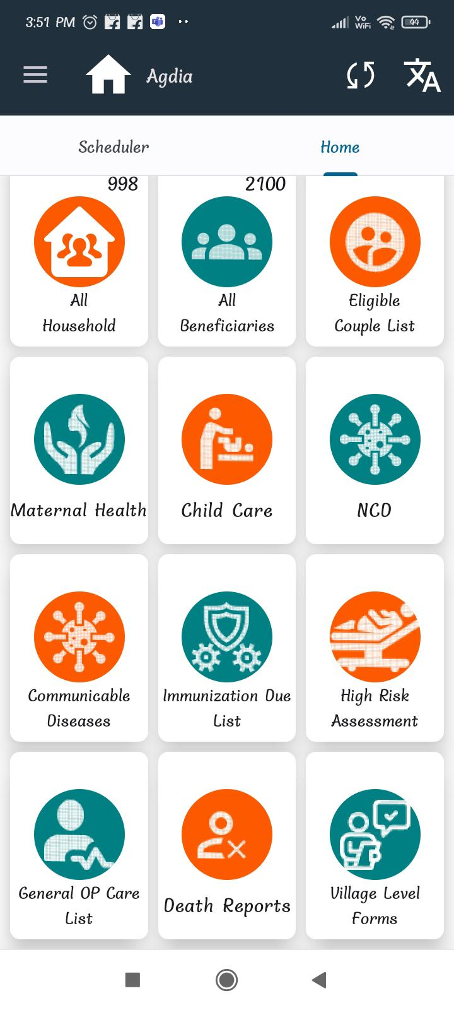
Click on New household Registration,
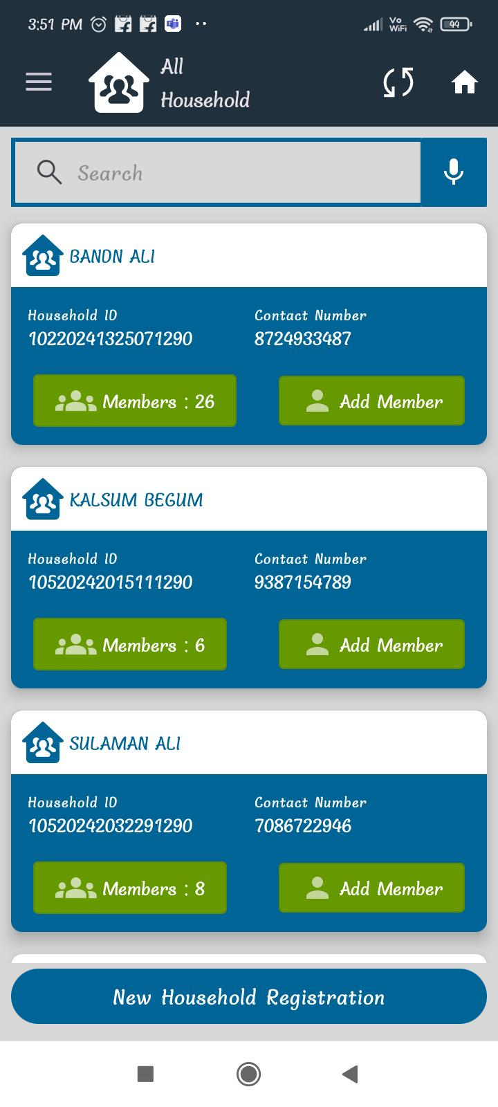
Select consent click on Agree,
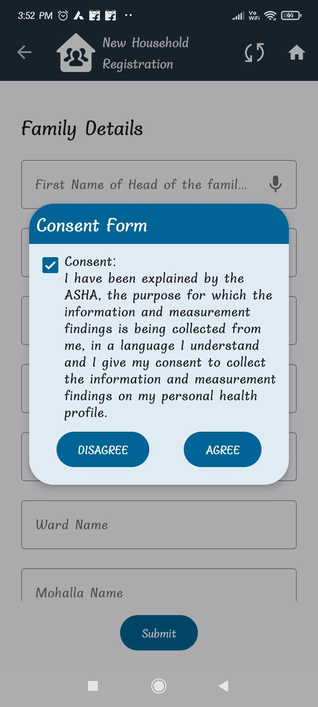

Here first Name and Last Name taking In capital letter,
