Auto-Move Beneficiary to TB Suspected List Post-Suspected TB under NCD Screening…..Jira ID 81………..
Click on NCD,
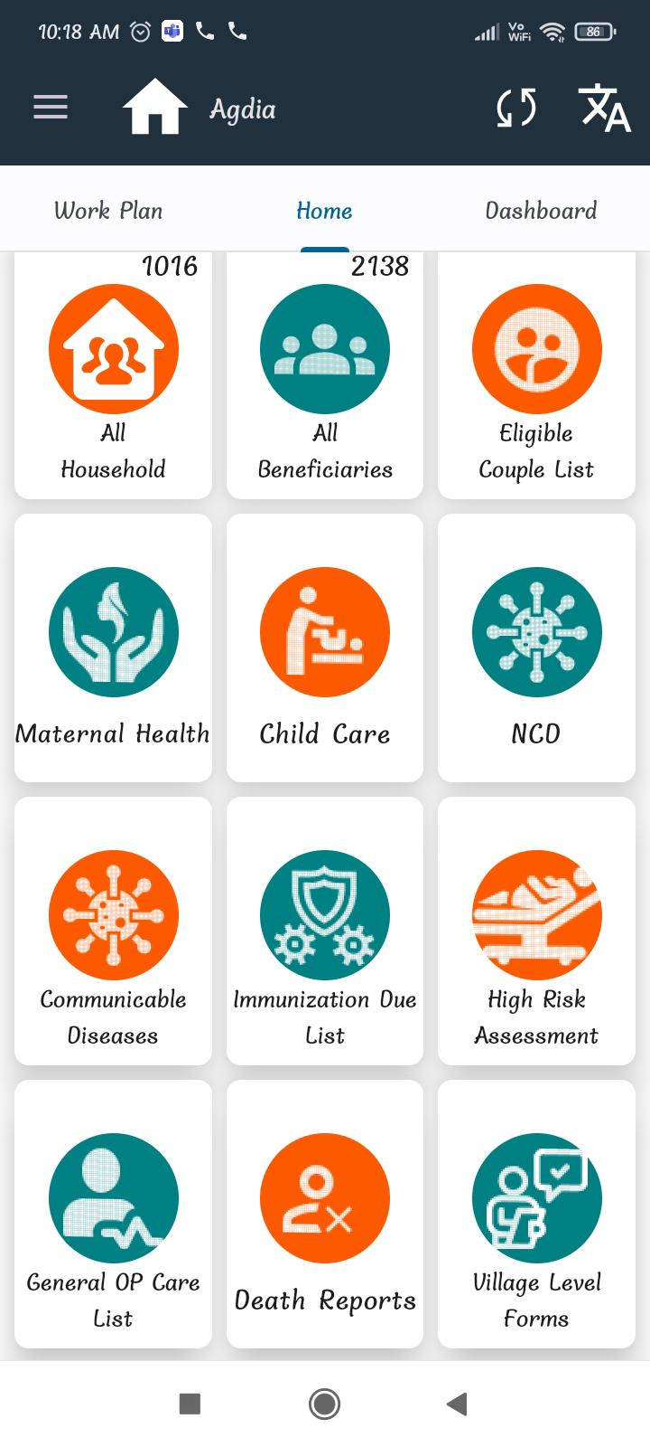
Click on NCD eligible list,
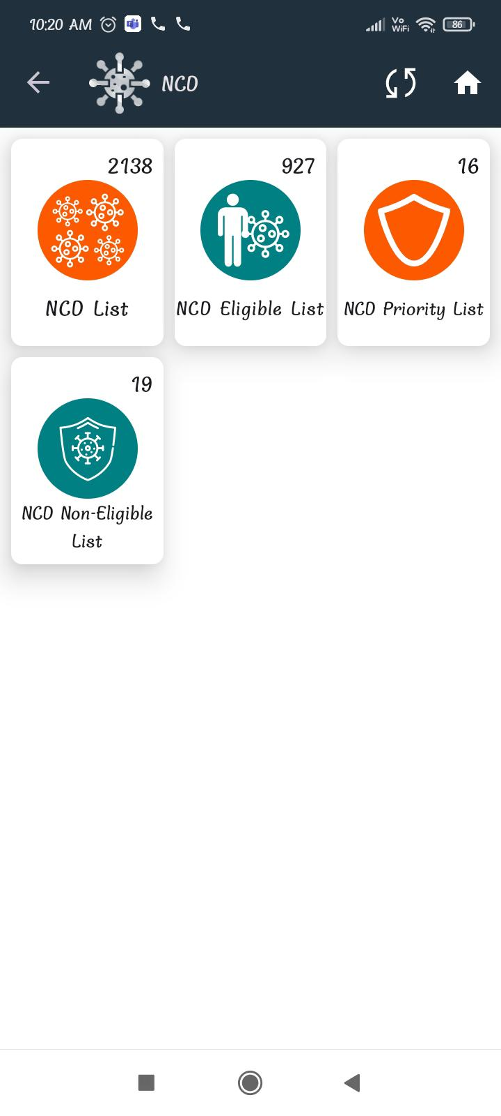
Fill all details like part A, B, C, D ,click all options “YES” and save it,
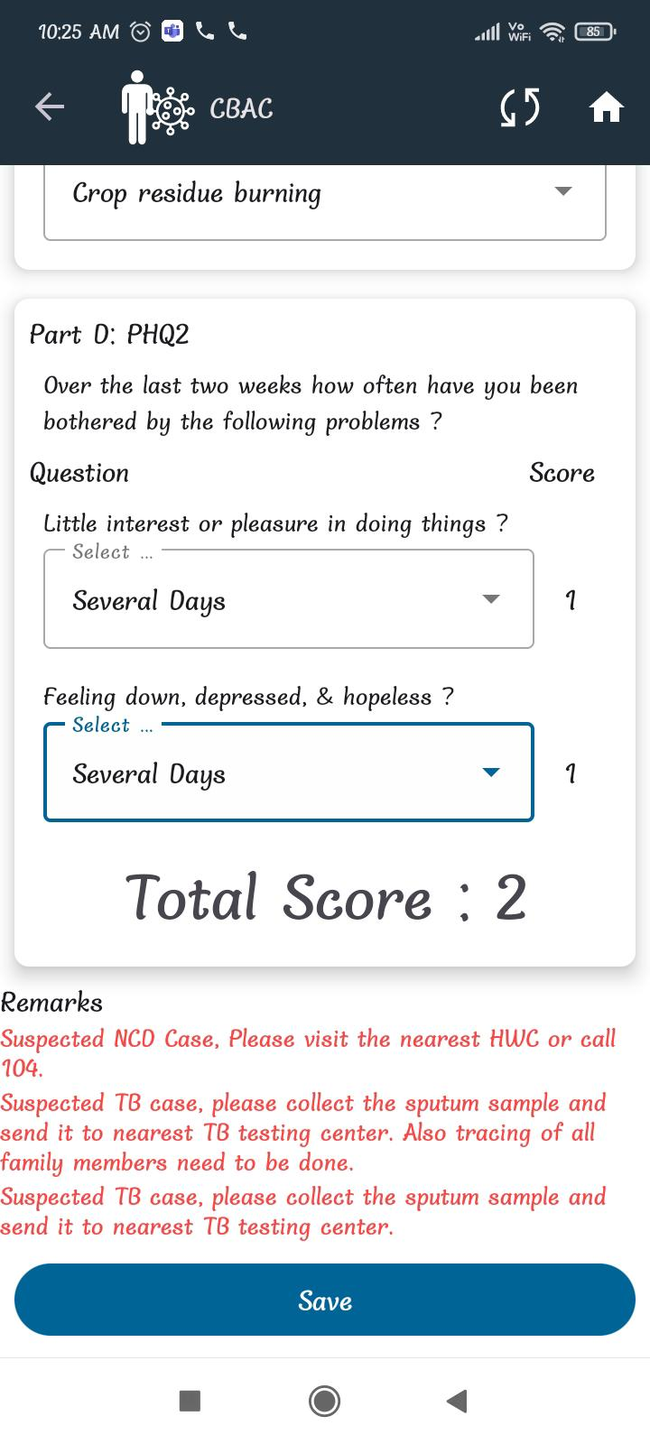
Now go to Communicable diseases,
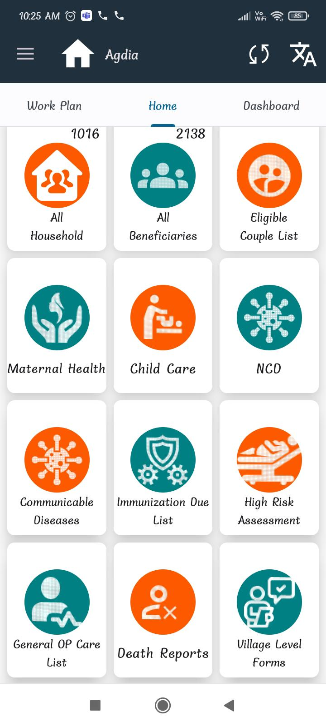
Click on Suspected TB cases,
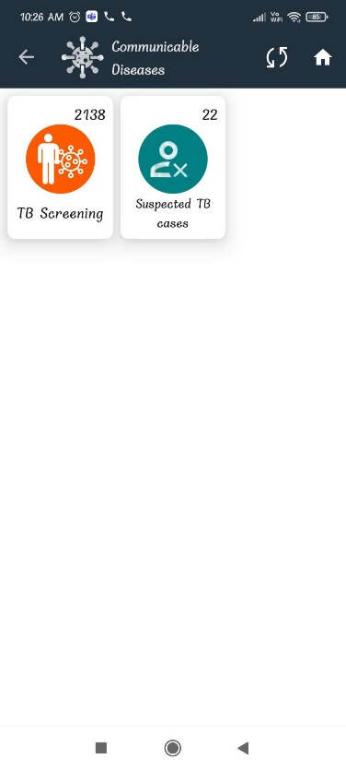

Here you can search beneficiary name like KABITA
Here record is coming,
