Incorrect Age Group Categorization in HBYC Module…Jira ID : 80
Choose English language Put username and password and click on login button,
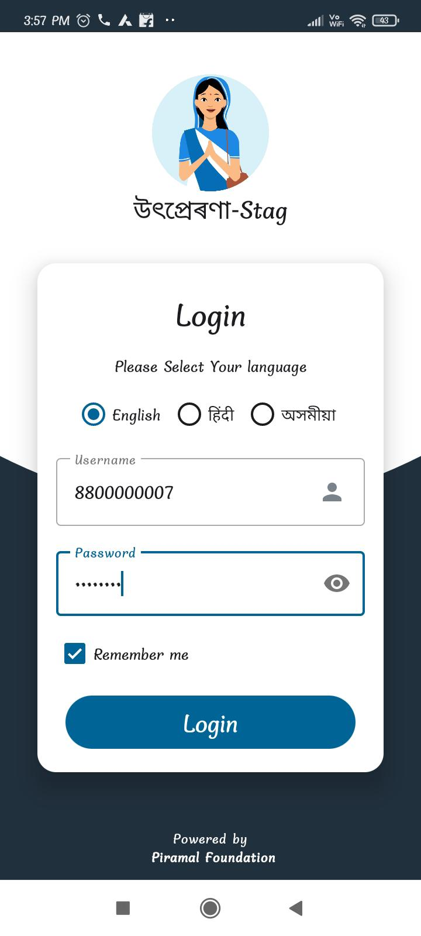
Click on “Child care”,
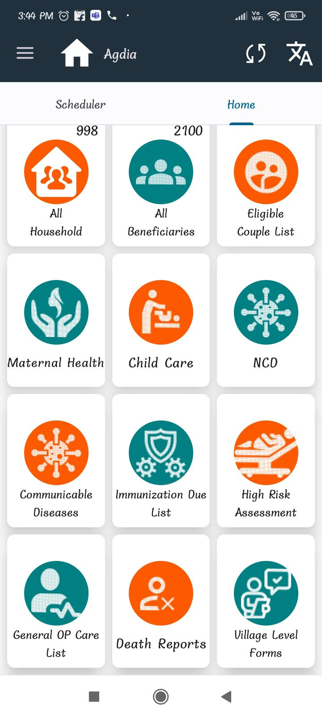
Click on “Child List”,
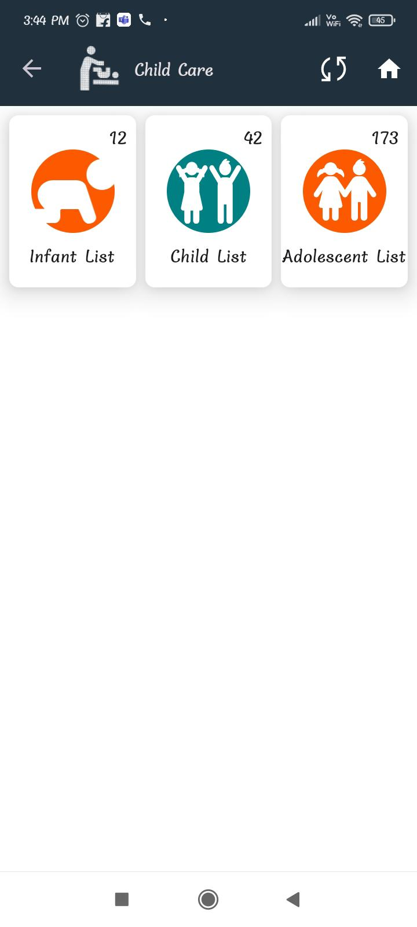
Here please check months there is no less 3 months,
